**Hardware Require:**

* ESP32
* 8x8 Dot Matrix LED
* MAX7219 LED Driver
* 0.1uF Non-Polarize Capacitor
* 10uF Polarize Capacitor
* 10k Resistor
* 5 Jumper Wire
* **8x8 Dot Matrix LED pinout:**

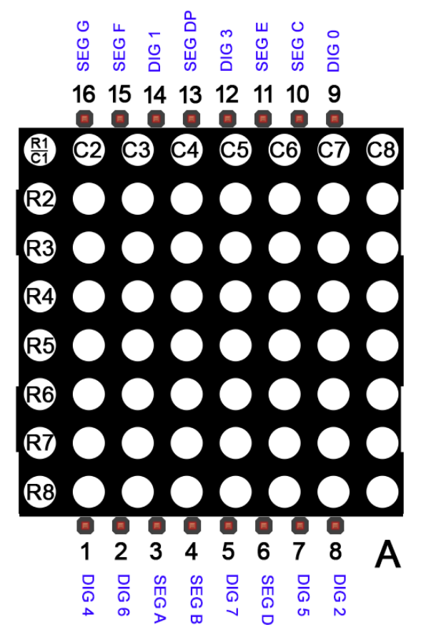

* **MAX7219 LED Drive IC Datasheet:**

[**https://www.analog.com/media/en/technical-documentation/data-sheets/MAX7219-MAX7221.pdf**](https://www.analog.com/media/en/technical-documentation/data-sheets/MAX7219-MAX7221.pdf)

**Hardware Connection:**

1. **Single 8x8 Dot matrix LED connection to MAX7219 LED Driver**

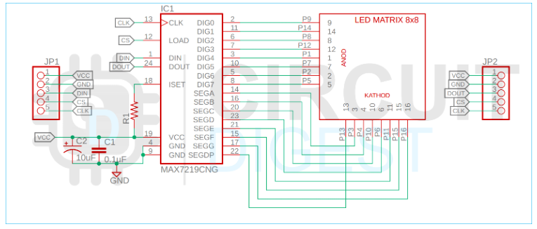

**2) 4 8x8 Dot matrix LED connect to MAX7219 LED Driver and Drive connect to MCU**

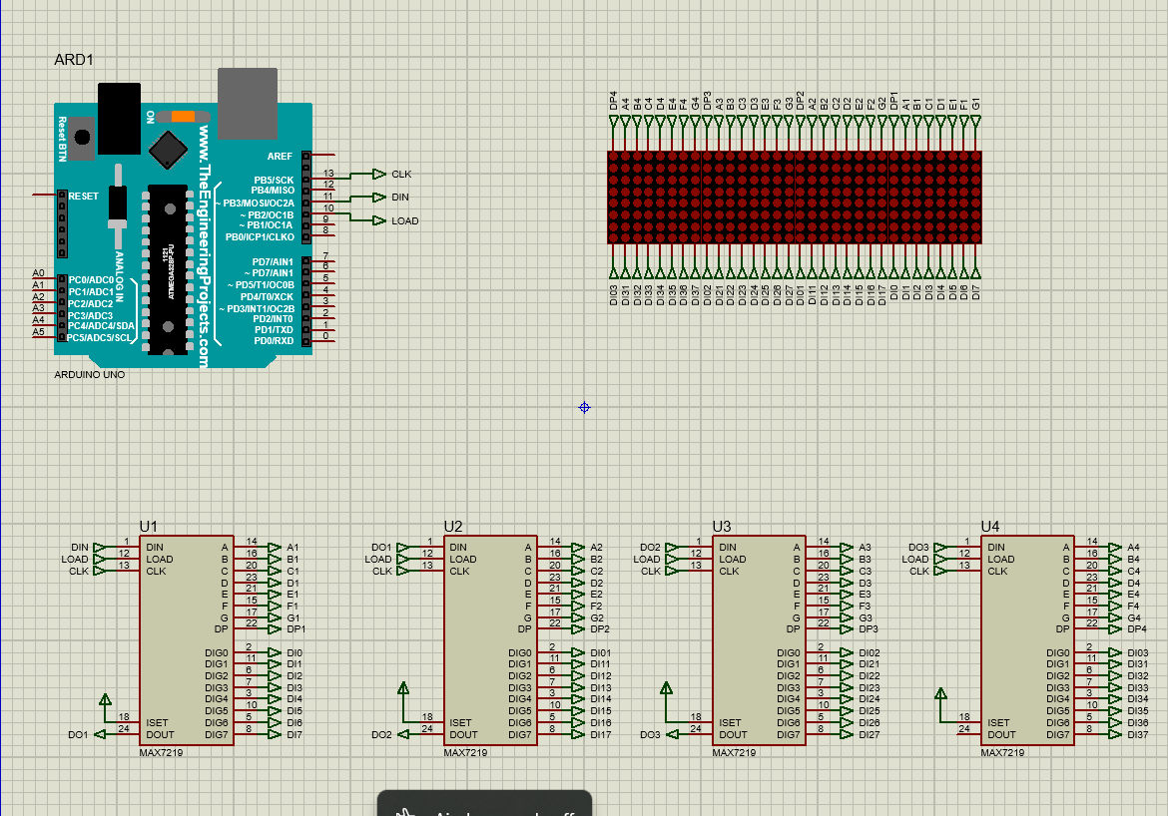

**Proteus 8 Simulation Software:**

* [**Proteus 8.13 SPO PRO.zip**](https://nxon-my.sharepoint.com/:u:/g/personal/ravi_prajapati_nxon_io/EVTJB7vqmMFCsp9zJyjzK3oBGCzmnWQYQ0KUOVFcvCRtmQ?e=rqAOm0)

**Example Code Flash in Arduino uno:**

* **This zip file is Proteus Project:**

[**Dot-Matrix-Proteus.zip**](https://nxon-my.sharepoint.com/:u:/g/personal/ravi_prajapati_nxon_io/EQRk3GYXg5ZDoy2uFXmRMDIBVw9oM9OWG_pL8ej9FLAUMQ?e=qkx5sC)

* **This zip file is Example code:**

[**8x8 Dot-Matrix-code.zip**](https://nxon-my.sharepoint.com/:u:/g/personal/ravi_prajapati_nxon_io/EfRTHqW1uMBHrAEDkQHbWKIBXMjcgCoFz6D8VipaKRfuxA?e=4rUzb3)